FIN 810 Financial Analytics

Midterm exam 2019

Name:___________________________

1. Write down your main answers in the exam paper. Email your analysis (EXCEL/SAS code/SAS log/SAS result) to [xz4@stmarys-ca.edu](mailto:xz4@stmarys-ca.edu).
2. Keep 4 decimal places for all your answers.

Part One: Excel Questions (10 points)

1. The table below gives a portfolio’s annual total return for a 12-year period ending in 2016.

|  |  |
| --- | --- |
| 2005 | -7.14% |
| 2006 | 1.62% |
| 2007 | 2.48% |
| 2008 | -2.59% |
| 2009 | 9.37% |
| 2010 | -0.55% |
| 2011 | -0.89% |
| 2012 | -9.19% |
| 2013 | -5.11% |
| 2014 | -0.49% |
| 2015 | 6.84% |
| 2016 | 3.04% |

1. Find the geometric mean of the portfolio’s return (you can use Excel)

| **Geometric Means** | | |
| --- | --- | --- |
| **Variable** | **Geometric Mean** | **Std Error** |
| **return_1** | 0.996482 | 0.015602 |

Geometric mean=0.996482-1=-0.003518

1. Find the arithmetic mean of the portfolio’s return.

-0.0021750

1. Which one will be a better estimate for the portfolio’s performance (annual return) for the 12 years period? And why? (No more than 50 words).

Geometric mean for time series of returns to reflect the growth rate.

Part Two: SAS questions: Stock NVIDIA

Use the NVIDIA’s weekly data from Yahoo Finance from 1/3/2016-12/31/2018. The screen shot of data download is as follows. The data is on SAS studio, Middle term exam.

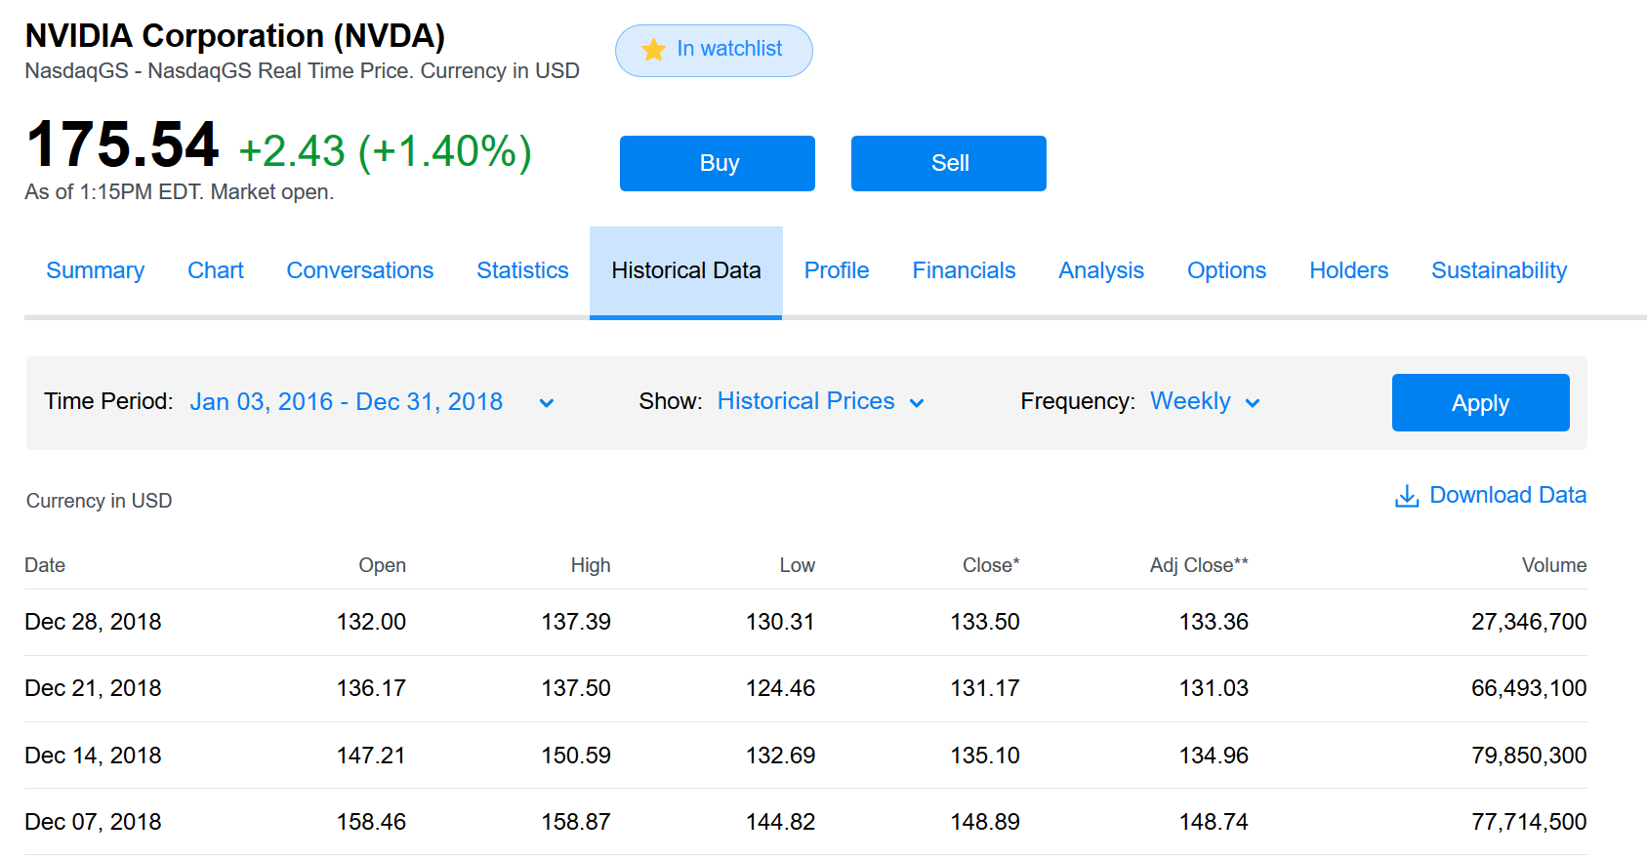

1. Statistics of NVIDIA weekly returns (Use SAS. Please submit SAS codes) (40 points)
2. Arithmetic mean

0.01177757

**The UNIVARIATE Procedure**

**Variable: NVDA_return**

| **Moments** | | | |
| --- | --- | --- | --- |
| **N** | 156 | **Sum Weights** | 156 |
| **Mean** | 0.01177757 | **Sum Observations** | 1.83730116 |
| **Std Deviation** | 0.06594415 | **Variance** | 0.00434863 |
| **Skewness** | 0.67727404 | **Kurtosis** | 7.90011281 |
| **Uncorrected SS** | 0.69567668 | **Corrected SS** | 0.67403774 |
| **Coeff Variation** | 559.912942 | **Std Error Mean** | 0.00527976 |

| **Basic Statistical Measures** | | | |
| --- | --- | --- | --- |
| **Location** | | **Variability** | |
| **Mean** | 0.011778 | **Std Deviation** | 0.06594 |
| **Median** | 0.016159 | **Variance** | 0.00435 |
| **Mode** | . | **Range** | 0.64828 |
|  |  | **Interquartile Range** | 0.05997 |

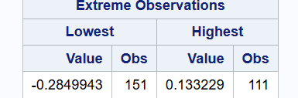

1. The 95th percentile

| **5th Pctl** | **95th Pctl** |
| --- | --- |
| -0.0789763 | 0.1079246 |

1. A 90% Winsorized mean, which one of the following statement is correct?__B____
2. Set the bottom 10 percent of values equal to the 10th percentile value.
3. Set the upper 5 percent of values equal to the 95 percentile value; Set the bottom 5 percent of values equal to the 5th percentile value.
4. discard the lowest 5% and the largest 5% of values.
5. discard the lowest 10% and the largest 10% of values.
6. None of the above.
7. For NVDA’s weekly returns, find ONE of the following two: either the 90% Winsorized mean; or the 90% trimmed mean.

Excel trimmed mean: =trimmean(data, 0.9)

<http://support.sas.com/documentation/cdl/en/procstat/66703/HTML/default/viewer.htm#procstat_univariate_syntax01.htm>

TRIMMED=values <(<TYPE=keyword> <ALPHA= $\alpha $>)>   
TRIM=values <(<TYPE=keyword> <ALPHA= $\alpha $>)>

requests a table of trimmed means, where *value* specifies the number or the proportion of observations that PROC UNIVARIATE trims. If the *value* is the number $n$of trimmed observations, $n$must be between 0 and half the number of nonmissing observations. If *value* is a proportion $p$between 0 and ½, the number of observations that PROC UNIVARIATE trims is the smallest integer that is greater than or equal to $np$, where $n$is the number of observations.

proc univariate data=nvda1 trimmed=.1 winsorized=.1;

var nvda_return;

run;

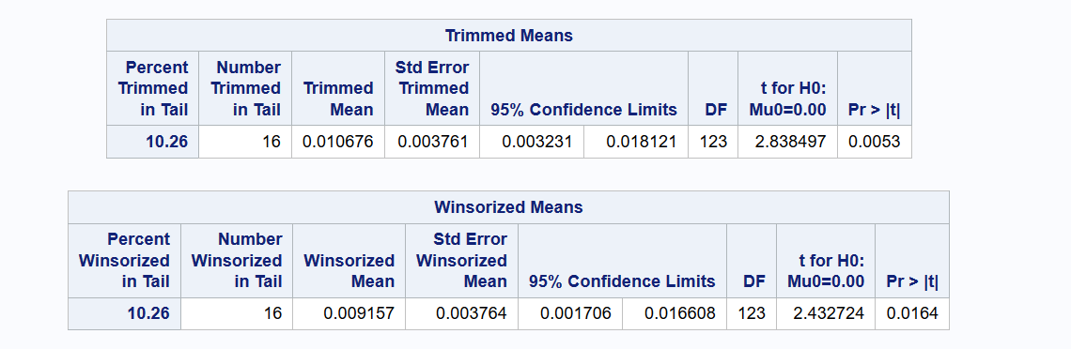

Here the percentile is 10.26% by changing 16 observations

If you use the definition of winsorized and trimmed, you can also get the following by changing 17 observations:

90% winsorized mean

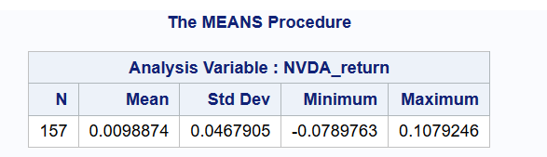

winsorized means (delete the missing value)

The MEANS Procedure

| **Analysis Variable : NVDA_return** | | | | |
| --- | --- | --- | --- | --- |
| **N** | **Mean** | **Std Dev** | **Minimum** | **Maximum** |
| 156 | 0.0104571 | 0.0463918 | -0.0789763 | 0.1079246 |

90% trimmed mean

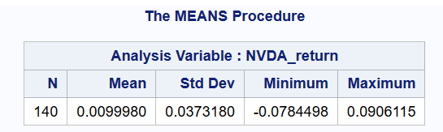

1. Standard deviation

0.06594415

1. Median

0.016159

1. Median absolute deviation

The MEANS Procedure

| **Variable** | **Mean** | **Median** |
| --- | --- | --- |
| **absmean**  **absmedian** | 0.0438210  0.0437263 | 0.0299941  0.0294018 |

Mean ( abs (x-median)): 0.0437263

Median (abs (x-median))= 0.0294018

1. Semi-deviation

(use the definition from <https://www.investopedia.com/terms/s/semideviation.asp>)

The formula for semi-deviation is:

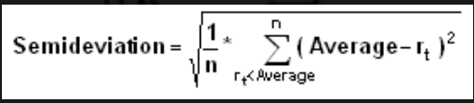

Where:

* *n* = the total number of observations below the mean (Different from the textbook’s definition)
* *rt* = the observed value
* *average* = the mean of a data set

| **downsiderisk** |
| --- |
| 0.063369 |

1. The modal interval of the ten equally spaced grouped returns

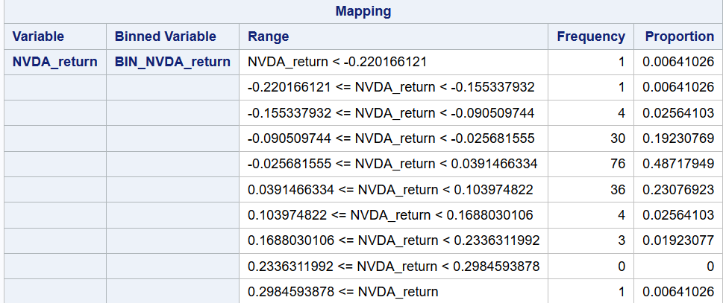

Modal interval:

|  |  |  |
| --- | --- | --- |
| -0.025681555 <= NVDA_return < 0.0391466334 | 76 | 0.48717949 |

1. Skewness:

0.67727404

|  |  |
| --- | --- |
| **Kurtosis** | 7.90011281 |

1. Do NVDA’s weekly returns have a symmetrical distribution?
   1. Yes
   2. No

B

1. Consider the figures below. Which figure is more likely to represent NVDA’s weekly returns’ distribution?

A.

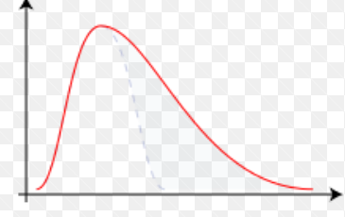

B.

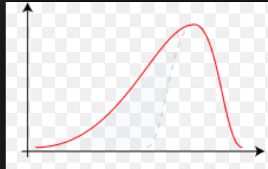

C.

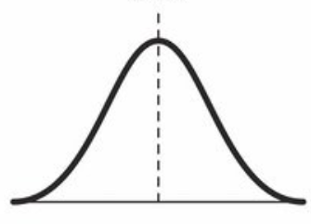

* + - Positively skewed (skewed to the right)
      * Long tail on the right side

A

(slides 03-45 text p131

13) Kurtosis

|  |  |
| --- | --- |
| **Kurtosis** | 7.90011281 |

14) NVDA’s weekly return’s distribution is a

A. leptokurtic

B. platykurtic

C. mesokurtic (identical to the normal distribution)

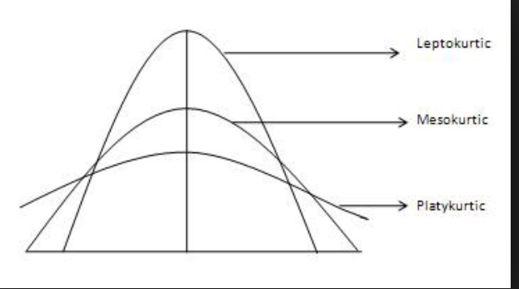

A

Slide 3-49

Text 135

15) Does NVDA’s weekly return have a normal distribution? Briefly list three reasons (no more than 30 words)?

* 1. 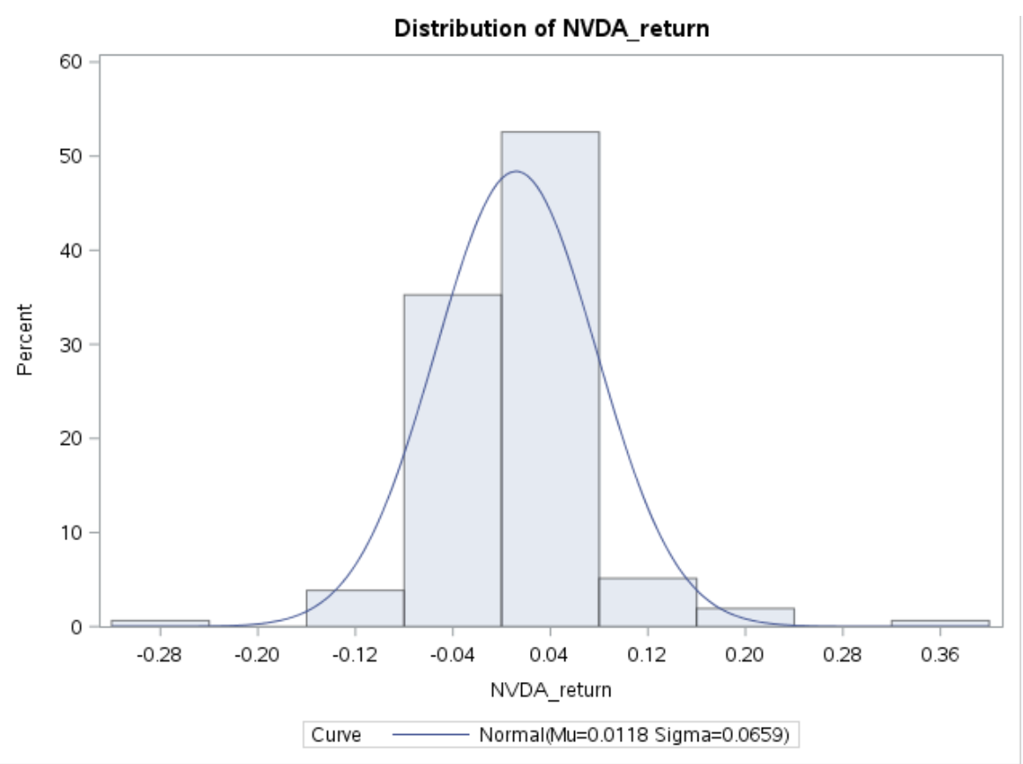

The histogram is not well aligned with the normal distribution curve.

* 1. Non symmetric, Positively skewed (skewed to the right)
  2. Leptokurtic (fat tail distribution)

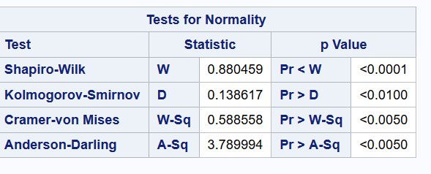

From proc univariate

Tests for normality (p values <0.01, significant at 0.01) reject H0: normal distribution.

1. Comparison between NVDA and Russell 3000. (20 points)

The Russell 3000 Index is a capitalization-weighted stock market index, maintained by FTSE Russell, that seeks to be a benchmark of the entire U.S stock market ([Wikipedia](https://en.wikipedia.org/wiki/Russell_3000_Index))

Use the Russell 3000 Index’s weekly data from Yahoo Finance from 1/3/2016-12/31/2018. The screen shot of data download is as follows. The data is on SAS studio, Middle term exam.

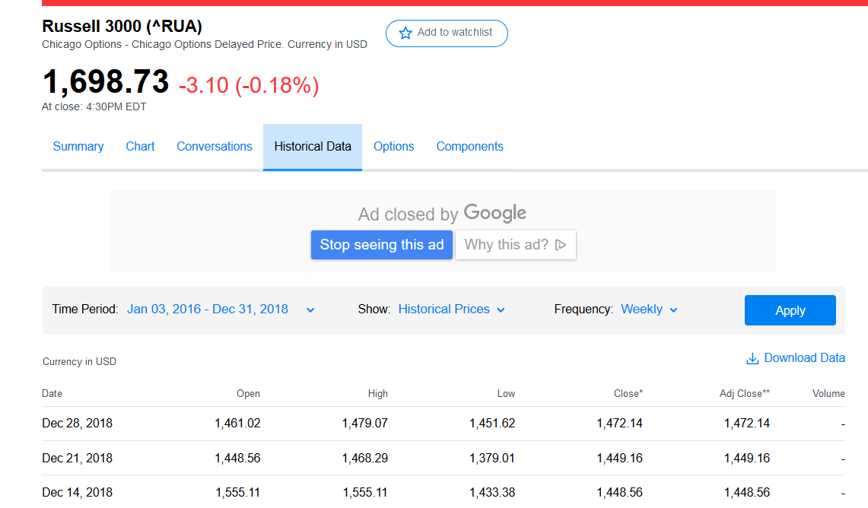

Use US 1-month T-bill rate to proxy for the risk free asset. The data is from <https://www.treasury.gov/resource-center/data-chart-center/interest-rates/Pages/TextView.aspx?data=yield>

The 1-month T-bill rate from 2016 to 2018 (quoted daily, percentage signs are omitted) is on SAS studio, Middle term exam.

1) You are a risk-averse investor. If the annual acceptance rate is 3%, please fill the table below.

|  |  |  |
| --- | --- | --- |
| 2016-2018 | Russell 3000 | NVIDIA |
| Weekly return’s mean | .001780786 | 0.011778 |
| Weekly return’s standard deviation | 0.018190 | 0.065944 |
| Sharpe ratio | 0.087537 | 0.17574 |
| Safety first ratio | 0.066184 | 0.16985 |
| Probability of return less than the acceptable level | 0.47362 | 0.43256 |

NVDA_results



2) Which one (Russell 3000 or NVIDIA) is more appealing to you and why. (Open question, no more than 80 words)?

NVDIA seemed more attractive. But it’s a simple stock with more individual volatility; Russell 3000 is an index with more balanced risk.

1. NVDA CAPM (30 points)

Use the CAPM model:

Rit - Rft= αi + βi *(Rmt - Rft) +εit

One-month T-bill rate is a proxy for the risk free asset.

Russell 3000 is a proxy for the market portfolio.

1. Provide the following regressions:

|  |  |
| --- | --- |
| CAPM model | NVIDIA |
| Intercept | 0.00702 |
| Intercept’s p value | 0.0874 (significant at 10%) |
| Beta coefficient | 1.79394 |
| Beta’s P value | <.0001 |

The REG Procedure

Model: capm

Dependent Variable: rp

|  |  |
| --- | --- |
| **Number of Observations Read** | 153 |
| **Number of Observations Used** | 153 |

| **Analysis of Variance** | | | | | |
| --- | --- | --- | --- | --- | --- |
| **Source** | **DF** | **Sum of Squares** | **Mean Square** | **F Value** | **Pr > F** |
| **Model** | 1 | 0.16426 | 0.16426 | 64.84 | <.0001 |
| **Error** | 151 | 0.38252 | 0.00253 |  |  |
| **Corrected Total** | 152 | 0.54678 |  |  |  |

|  |  |  |  |
| --- | --- | --- | --- |
| **Root MSE** | 0.05033 | **R-Square** | 0.3004 |
| **Dependent Mean** | 0.00952 | **Adj R-Sq** | 0.2958 |
| **Coeff Var** | 528.90459 |  |  |

| **Parameter Estimates** | | | | | |
| --- | --- | --- | --- | --- | --- |
| **Variable** | **DF** | **Parameter Estimate** | **Standard Error** | **t Value** | **Pr > |t|** |
| **Intercept** | **1** | 0.00702 | 0.00408 | 1.72 | 0.0874 |
| **Mrp** | **1** | 1.79394 | 0.22279 | 8.05 | <.0001 |

1. R square: __________. Briefly explain the statistical meaning of the r square. (less than 20 words)

0.30

30% change of Y variable (the excess return of NVDA over t bill) can be explained by the X variable (the excess return of Russell 3000 over t bill)

1. Is NVIDA’s beta larger than 1, or less than 1? What is the economic meaning? (less than 20 words)

Larger than 1, more risk than the market portfolio

1. Does NVIDA have a statistically significant alpha? If yes, what is the economic meaning? (less than 20 words)

If the cut off is 10%,

10% significant. In addition to CAPM model predicted return (or the return compensated to the risk level beta), NVDA provides additional return 0.00702 weekly.

Yahoo Finance’s [beta](http://investexcel.net/calculate-stock-beta-with-excel/) is calculated from monthly price for the previous 36 months, relative to the S&P 500.

|  |  |
| --- | --- |
| Quote from Yahoo Finance (5/7/2019): Beta (3Y Monthly) of NVDA is | 2.28 |

1. Briefly list three reasons why your beta value is different from Yahoo Finance.
2. Data frequency: yahoo monthly; our weekly
3. Time horizon: yahoo is over the 3 yr (may 2019-april 2016), our is 3y daily (2016-2018)
4. Proxy: yahoo use S&P500 for market portfolio; our use Russell 3000 for market portfolio.
5. If I expect the market risk premium is 6% p.a. in 2019 and the risk free rate is 3% p.a. in 2019, use your regression estimate to find: NVDA’s annual return.

weekly

Y=0.00702+1.79394*(6%/52)= 0.00909

Nvda_return (weekly)-3%/52=0.00909

Nvda_return (weekly)=0.00909+3%/52=0.00967

Nvda_return (annual)= 0.00967*52=0.50268